**Department of Computer Engineering**

**University of Peradeniya CO226-Database Systems**

Exercise: 01

Topic: Introduction to MySQL

Lab Date: 08/12/2021

Reg. No: E/18/397

01) Display all the existing databases in MySQL server host.

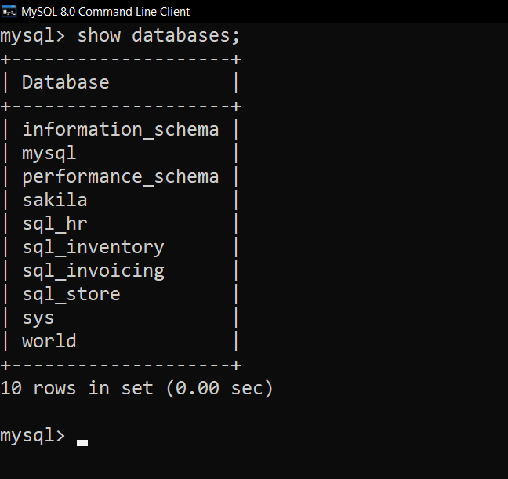

02) Create a database called “BookShop”.

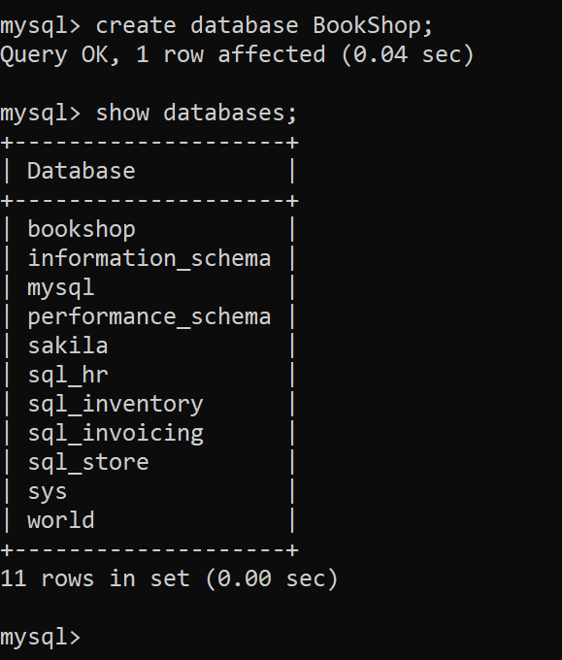

03) Select or access the “BookShop” database.

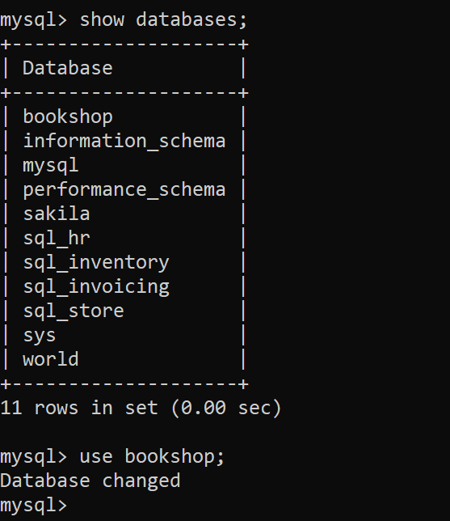

04) Within that database, create a table called “Book” with the following fields.

|  |  |  |
| --- | --- | --- |
| **Field Name** | **Type** | **Field Size** |
| BooklD | Text | 5 |
| Title | Text | 50 |
| Author | Text | 30 |
| Category | Number |  |
| Price | Currency | (8,2) |
| PubID | Text | 6 |

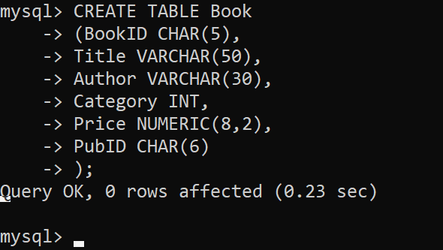

05) Display the structure of the “Book” table.

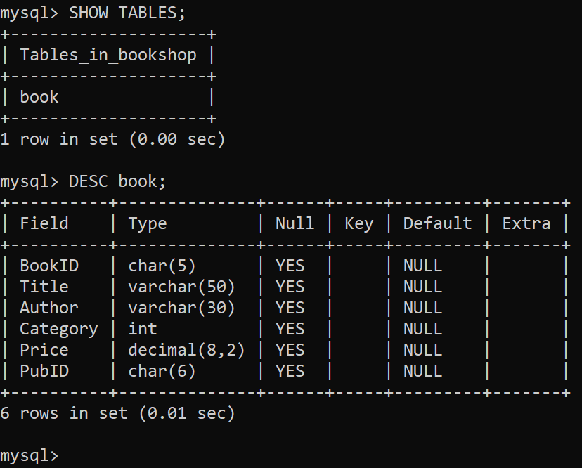

06) Create another table called “Publisher” with the following fields.

|  |  |  |
| --- | --- | --- |
| **Field Name** | **Type** | **Field Size** |
| PublD | Text | 6 |
| PublisherName | Text | 30 |
| RegisteredDate | Date |  |
| Country | Text | 15 |

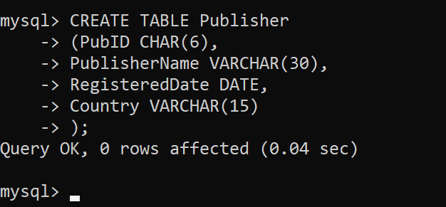

07) Display the structure of the “Publisher” table.

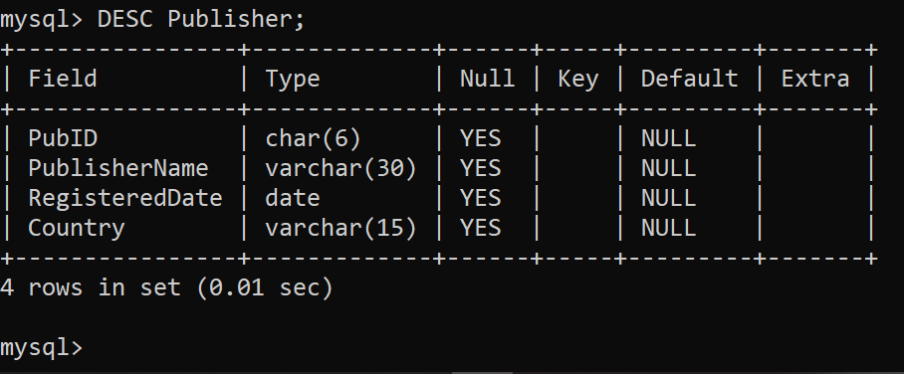

08) Display all the tables in the “BookShop” database.

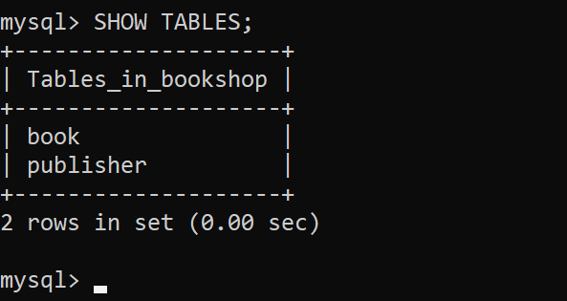

09) Remove the table “Book”.

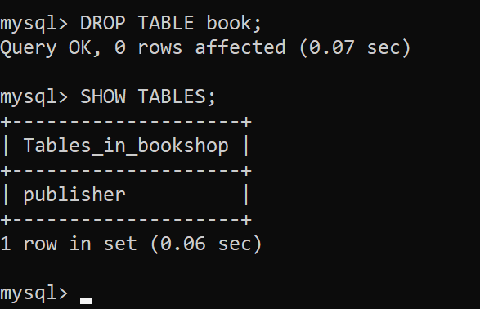

10) Remove the database “BookShop”.

